(Triple Threat)
(A Blackjack Game)

Software Design Document

Names: Hannah Portillo, Nathaniel Payne, and Muhammad Numan
Course Section: CIS-2790-HY003
School: College of Dupage

Date: (03/5/2026)

Revision History
Name | Date | Reasons for Changes | Version
Hannah Portillo | 2/19/2026 | SWDD formatting and setup | 1.0
Nathaniel Payne | 2/25/2026 | Filling out section 1 and 2: Introductions and System Overview | 2.0
Hannah Portillo | 2/27/2026 | General edits and additions to Introduction and System Overview | 3.0
Hannah Portillo | 2/28/2026 | Filling out section 3: System Architecture | 4.0
Hannah Portillo | 3/1/2026 | Filling out section 3.3 – Design Rationale  Filling out section 4: Data Design | 5.0
Hannah Portillo | 3/2/2026 | Filling out section 6 - User Interface Design  6.1 - Overview of User Interface | 6.0
Hannah Portillo | 3/3/2026 | Filling out section 7 - Requirements Matrix table | 7.0
Muhammad Numan | 3/3/2026 | Filling out section 5 - Component Design | 8.0
Hannah Portillo | 3/3/2026 | General edits and revisions throughout: Sections 1, 2, 3, 4, 6, and 7 | 9.0
Muhammad Numan | 3/4/2026 | Filling out section 6 - all 3 parts | 10.0
Hannah Portillo | 3/4/2026 | Filling out section 8  Final edits and revisions throughout/finalization | 11.0

TABLE OF CONTENTS

1.0 INTRODUCTION 4
1.1 Purpose 4
1.2 Scope 4
1.3 Overview 4
1.4 Reference Material 5
2.0 SYSTEM OVERVIEW 5
3.0 SYSTEM ARCHITECTURE 6
3.1 Architectural Design 6
3.2 Decomposition Description 7
3.3 Design Rationale 9
4.0 DATA DESIGN 10
4.1 Data Description 10
4.2 Data Dictionary 11
5.0 COMPONENT DESIGN 13
6.0 USER INTERFACE DESIGN 15
6.1 Overview of User Interface 15
6.2 Screen Images 15
6.3 Screen Objects and Actions 16
7.0 REQUIREMENTS MATRIX 17
8.0 Ethical, Legal, and Security 18
8.1 Ethical Considerations 18
8.2 Legal Considerations 18
8.3 Security Considerations 19

INTRODUCTION

Purpose
This software design document describes the architecture and system design of the Blackjack game prototype. The intended audience of this document includes developers who may implement the Blackjack program, project team members, and any instructors or evaluators. This document will serve as the primary technical reference for coding and system implementation.
The purpose of this software is to provide a source of reusable entertainment. The target demographic is vast. People who like high stake games, people who like card games or someone who simply enjoys fun recreations of classic games we all know and love.

Scope
The intention of this software is to create a blackjack game using the basic fundamentals familiar to any given player with prior experience. In the circumstance of unfamiliar players to the software or game of Blackjack, we will provide a “How to play” guide or tutorial. The primary goal should be to accomplish all of traditional blackjack's basic functions. These functions are inclusive but not limited to: randomized card generation, hit/stand mechanics, multiplayer (offline), player betting, recurring player games/rematches, and more.
In short, the goals with this project are as follows:
- Provide a functional Blackjack game with GUI
  - Good experience for seasoned players
  - Good experience for new players (tutorial)
- Implement the correct Blackjack rules
- Allow player interaction through the use of buttons
  - Hit
  - Stand
  - Replay/Exit

Overview
This document and software encompass an array of code that collectively creates the functionality of our Blackjack game application. The program is organized primarily using functions to highlight distinct game/system features. These functions are conglomerated together in various ways; one being through the main function. Values and strings are extracted from lists and dictionaries. These same arrays and dictionaries hold player’s information (ex. name, bet, hand, value etc.). There are also various loops and statements scattered throughout to help the program run efficiently and clearly.
Overall, this document will describe:
- System architecture
- Program functions
- Descriptions of data
- Component design
- User interface design
- Ethical, legal, and security measures

Reference Material
The SWDD References are as follows:
- IEEE 830 Software Requirements Specification Standard
  - chrome-extension://efaidnbmnnnibpcajpcglclefindmkaj/IEEE Recommended Practice for Software Requirements Specifications
- Course textbook and lecture materials
  - Satzinger, John W., Robert B. Jackson, and Stephen D. Burd. Systems Analysis and Design in a Changing World. 7th ed., Cengage Learning, 2016.
- Blackjack rules
  - Traditional Blackjack rules apply: https://bicyclecards.com/how-to-play/blackjack
- Python Software Foundation. Python Documentation. The latest version. https://docs.python.org/3/

SYSTEM OVERVIEW

The functionality of the system is as follows. Our Blackjack program will involve accepting multiple players in which they can all place bets. When a player wins a round they are awarded double the quantity they chose to bet. If multiple players win then it becomes a push (tie) and bets are returned between the selected players. Players with a lower hand value lose the money that they had bet. Players will receive their cards and will be on display for others to view. With these cards they can either choose to ‘hit’ or ‘stand’. These are two fundamental game features. If a player busts (value over 21), their hand value drops to 0 and if a player receives blackjack then they automatically stand. Replay features are prompted at the end of each game. If replay is selected, the same players will carry over with the same money they either won or lost. If a player no longer has money to play with then they’re excluded from the game. Starting a new game will refresh the lobby of players and the money/bets.

The system is designed to provide end-users with an interactive, rule-compliant, fair, and a user-friendly experience. The system will support multiple players in an offline mode.

SYSTEM ARCHITECTURE

Architectural Design
The Blackjack game follows a functional, modular architecture centered around the function (main()). This primary function coordinates several supporting modules. The responsibilities of the program are split between different subsystems; each subsystem handles one major part of gameplay. The subsystems collaborate, primarily, by passing dictionaries/lists between functions and by updating shared state (such as player totals and bets).

The following are high-level subsystems and their responsibilities within the program:
- Game Coordinator Subsystem (main)
  - Controls the flow of the application
  - Initialized dealer hand
  - Gather players and bets
  - Executes turn logic
  - Determines winners and payouts
  - Manages replay or game exit
- Player Setup and Initial Deal Subsystem (dict_list, user)
  - Collects player names and deals the starting hands.
  - Determines initial totals and stores them in the player total repository.
- Dealer/House Subsystem (dealer)
  - Deals the dealer’s starting hand.
  - Stores dealer cards in the house repository.
- Turn Processing Subsystem (hit_or_stand)
  - Manages interactive hit or stand decisions for each active player.
  - Updates player totals during the round.
  - Marks busts by setting totals to 0.
- Outcome Evaluation Subsystem (check_winners)
  - Determines the highest final hand value among players.
  - Returns the player/s who match that highest value.
- Payout/Settlement Subsystem (pay_winner)
  - Calculates payout based on winners and their bets.
  - Produces a total payout amount for the round.

Subsystem flow summarized:
The game coordinator subsystem triggers the setup of dealer and players, collects bets from players, and launches the game’s turn based gameplay. The turn processing subsystem updates totals into final round values. The outcome evaluation subsystem reads those final round values and determines a winner (the outcome). The payout subsystem uses winners and their bets to compute winnings. We return to the game coordinator subsystem after a game to either reset values in order to replay or exit the game.

Decomposition Description

The system design for the Blackjack game follows a functional decomposition design approach. The system is decomposed into functions that allow for the major processes of a Blackjack game to take place:

Top-Level Functional Decomposition
- Main game flow – main()
- Initial dealing – user(), dict_list(), dealer()
- Player turn loop – hit_or_stand()
- Determine winners – check_winners()
- Determine payout – pay_winner()

Structural Decomposition Diagram
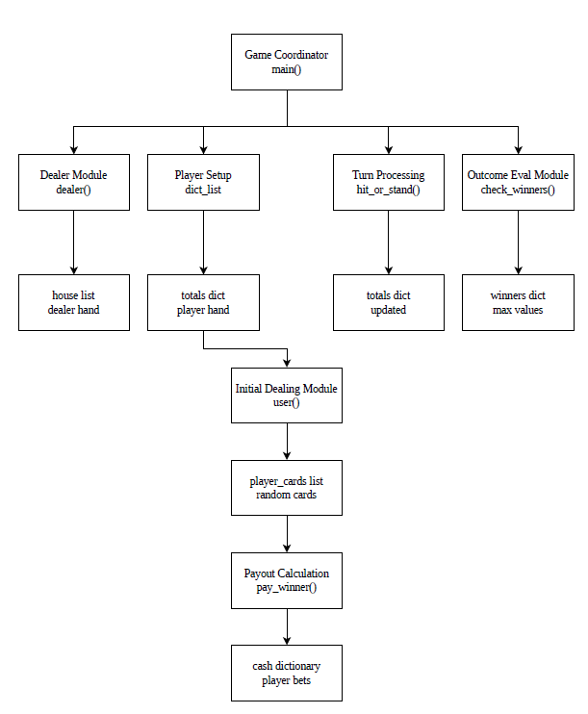

Explanation of Diagram:
The structural decomposition diagram shows how the Blackjack program is organized into several smaller functional modules. The main() function acts as the central controller for the program and manages the overall flow of the game. From there, the program calls other modules that handle specific parts of the system, such as: dealing the dealer’s cards, setting up the players, processing player turns, determining the winner, and calculating payouts.
There are several shared data structures that are used to keep track of the game state. For example, the house list stores the dealer’s cards, the totals dictionary keeps track of each player’s current hand value, the winners dictionary identifies the player or players with the highest score, and the cash dictionary stores the bets placed by each player.
Dividing the program into smaller modules enables the system to become easier to understand, maintain, and modify. Each module focuses on one specific task while at the same time all modules work together with each other to complete a full round of Blackjack gameplay.

Design Rationale
This architecture for the Blackjack game application was selected for three main reasons: the simplicity and readability of the program, the separation of concerns for the program, and the ease of implementation. Regarding simplicity and readability, a single main function with helper functions makes the program easy to follow for a console-based Blackjack game. Regarding the separation of concerns and responsibilities for the program, the game setup, turn logic, winner evaluation, and payout are all separated into distinct functions. This reduces duplicated code/logic and keeps functions, and the program as a whole, focused and organized. Regarding the ease of implementation, the program is interactive, single-session, offline, and console based so approaching the design with these things in mind makes the functional and modular design an easy choice.

DATA DESIGN

Data Description
The Blackjack game’s system data consists of players, bets, hands/totals, winners, and the dealer (house) hand. The program is functional and console-based thus these data structures are represented using Python built-in collections (dictionaries and lists) rather than classes or databases. All system data is in-memory only and is reset when the program ends.
The following is a description of each data component and how it is stored, organized, and processed.
      - Players
        - Stored - player names (str) used as dictionary keys
        - Organized – dictionaries
        - Processed - user input drives game decisions and bets; player totals are updated during gameplay
      - Bets
        - Stored - an integer bet per player in cash dictionary
        - Organized - cash dictionary; cash: dict[str, int]
        - Processed - read by pay_winner() to determine payout
      - Hands/Totals
        - Stored - an integer total per player in totals dictionary
        - Organized - totals dictionary; totals: dict[str, int]
        - Processed - updated by hit_or_stand() when player interact; a bust sets the total to zero.
      - Winners
        - Stored - dictionary returned from check_winners()
        - Organized - winners dictionary; winners: dict[str, int]
        - Processed – used in main() for printing win/tie messages and payouts
      - Dealer (house) hand
        - Stored - list of card values
        - Organized - house: list[int]
        - Processed - dealt once at the start with dealer()

Data Dictionary

System Entities/Data Structures Dictionary:

Name | Type | Description
Cash | Dictionary (dict[str, int]) | Stores each player's bet for the current round. The key is the player's name and the value is the bet amount.
FinalValues | Dictionary (dict[str, int]) | Stores the updated player totals returned from the hit_or_stand() function after all turns are completed.
House | List (list[int]) | Stores the dealer’s hand as a list of integer card values.
name_and_totals | Dictionary (dict[str, int]) | Stores each player's hand total after the initial cards are dealt. The key is the player name and the value is the current hand total.
PlayerList | List (list[int]) | Temporary list used when generating player cards inside the user() function.
PlayerMoney | Dictionary (dict) | Stores player bankroll totals across rounds.
play_again | Boolean (bool) | Controls whether the game loop continues or the program exits.
Totals | Dictionary (dict[str, int]) | Main repository storing player hand totals. It is updated during gameplay as players hit or stand.
Winners | Dictionary (dict[str, int]) | Stores the player(s) with the highest hand value after the round is complete. Used to determine who receives the payout.

Functions Dictionary:

Function | Parameters | Return Value | Description
main() | None | None | Controls the overall program flow including game startup, player input, turn processing, determining a winner, payout calculations, and replay logic.
dealer(houses_cards) | houses_cards (list[int]) | list[int] | Generates the dealer's starting hand and displays the dealer’s visible card.
dict_list(dict_totals, total_players) | dict_totals (dict[str,int]), total_players (int) | dict[str,int] | Collects player names, deals initial cards using the user() function, and stores player totals in the totals dictionary.
user(player_cards) | player_cards (list[int]) | (int, list[int]) | Generates two random cards for a player and calculates the total hand value.
hit_or_stand(DictTotals) | DictTotals (dict[str,int]) | dict[str,int] | Processes player turns by allowing each player to choose hit or stand. Totals are updated accordingly.
check_winners(final_values) | final_values (dict[str,int]) | dict[str,int] | Determines the highest hand value among players and returns a dictionary containing the winning player(s).
pay_winner(cash, winners, player_money) | cash (dict[str,int]), winners (dict[str,int]), player_money (dict) | (int, dict) | Calculates the payout amount for the winner(s) based on their bets and returns the total payout.

COMPONENT DESIGN

In this section, we take a closer look at what each component does in a more systematic way. Below is a summary of the Blackjack program’s algorithm for each function listed in section 3.2 using pseudocode:

FUNCTION user (player_cards)
GENERATE two random cards
ADD both cards to player’s hand
CALCULATE total

IF total > 21 AND a card is an Ace (11)
CHANGE Ace value to 1
UPDATE total
END IF

RETURN total and player cards
END FUNCTION

FUNCTION dict_list(dict_totals, total_players)
FOR each player from 1 to total_players
GET player name
CALL user to deal starting cards
STORE player total in dictionary
DISPLAY cards and total
END FOR

RETURN dictionary of player totals
END FUNCTION

FUNCTION dealer (houses_cards)
GENERATE two random cards for dealer
ADD cards to dealer hand
CALCULATE total

DISPLAY dealer’s first card

IF total equals 21
DISPLAY blackjack message
ELSE IF total > 21 AND card is Ace
CHANGE Ace to 1
UPDATE total
END IF

RETURN dealer cards

END FUNCTION

FUNCTION hit_or_stand (DictTotals)
CREATE list of active players

WHILE active players exist

FOR each active player

DISPLAY current total
ASK hit or stand

IF hit
GENERATE random card
ADD to total

IF total > 21 AND card is Ace
CHANGE Ace to 1
END IF

IF total > 21
SET player total to 0 (bust)
REMOVE player from active list
ELSE IF total = 21
REMOVE player from active list
END IF

ELSE
REMOVE player from active list
END IF

END FOR

END WHILE

RETURN updated totals

END FUNCTION

USER INTERFACE DESIGN

Overview of User Interface

The Blackjack game application will have an easy to use user interface with three main screens. It will have a main/welcome screen, a game screen, and a result screen. It will have prompts for user input displayed at the center of the screen. There will be several intuitively placed buttons for game interaction. It will display the player and dealer cards and totals throughout the game.

Screen Images

The following is a mockup of what the screens/GUI would look like if the user plays through one game of Blackjack. This is a conceptual design that is subject to change.
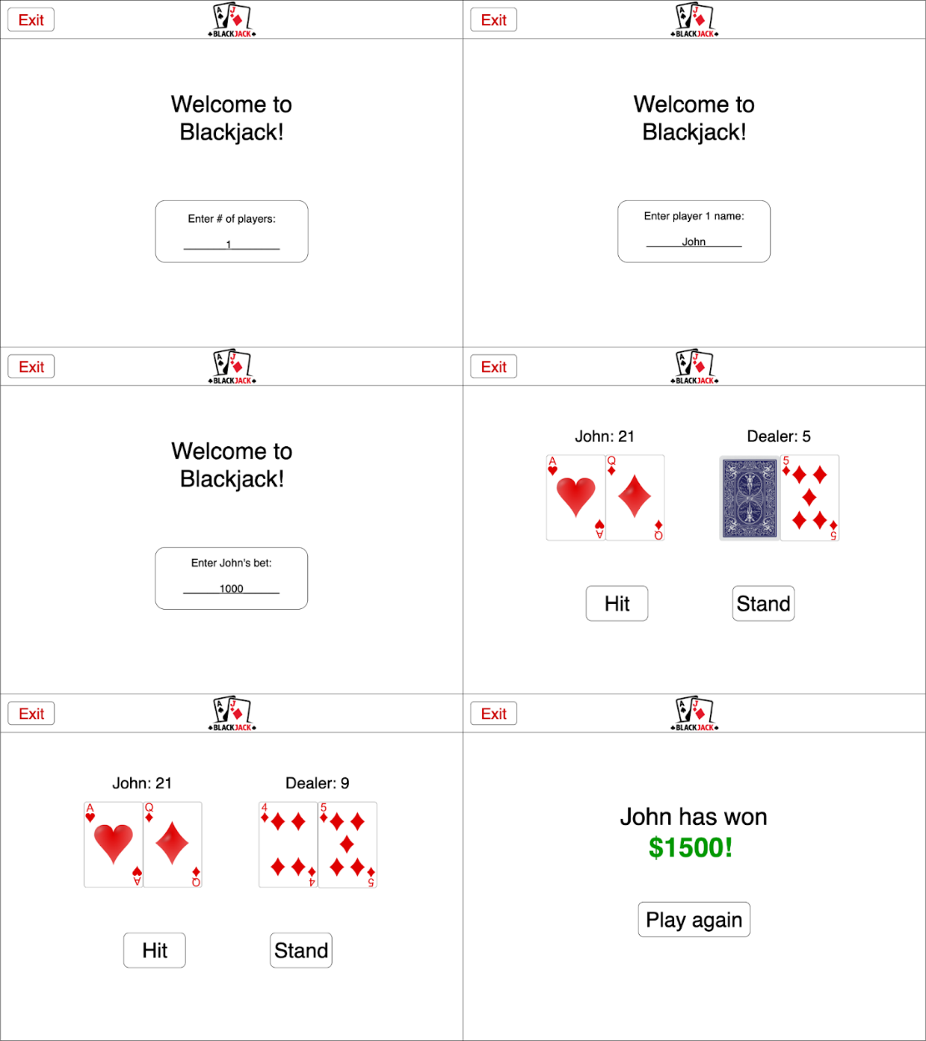

Screen Objects and Actions

A discussion and table of screen objects and actions associated with those objects.

Screen object | Actions
Text prompts | - Entry of # of players  - Entry of player names  - Player bets
Exit | Exit the game at any time
Hit | Hit for another card
Stand | Stay with current cards
Play again | Play another round

REQUIREMENTS MATRIX

The following table traces each system feature/functional requirement expressed in the SRS to the system components and functions defined in this SWDD.

Functional Requirement # | Description of Requirement | SRS Section/Reference | Implementing Components/  Functions | Description of Implementation
FR-1 | The system shall randomly generate and deal cards to the players and dealer at the beginning of each round. | 3.1 Player Card Randomization | user(), dealer() | These functions generate random card values for players and the dealer. They store card values in lists and calculate initial hand totals.
FR-2 | The system shall allow players to place bets and calculate winnings for the round. | 3.2 Player Bets and Winners ROI | main(), check_winners(), pay_winner() | The system collects player bets, determines the winning player/s, and calculates payouts based on the bet amounts.
FR-3 | The system shall allow the user to enter the number of players and each player's name before the game begins. | 3.3 Number of Players & Name Entry | dict_list() | This function collects player names, initializes player totals, and stores the information in dictionaries. This information is used throughout the game session.
FR-4 | The system shall allow players to choose whether to “Hit” or “Stand” during their turn. | 3.4 Hit or Stand | hit_or_stand() | This function manages player turns, processes hit or stand decisions, updates player totals, and determines bust conditions.
FR-5 | The system shall prompt the user to start a new game or exit the program after a round is completed. | 3.5 Play Again | main() | The main game loop prompts the user to replay the game or exit the program.

8.0 Ethical, Legal, and Security

8.1 Ethical Considerations

The Blackjack game application is designed for some educational but mostly recreational purposes only. The program simulates a traditional card game of Blackjack, but it does not involve real money, gambling, or financial transactions. The Blackjack program is intended to provide fair gameplay for all users by utilizing randomized card generation and applying the same and consistent rules to all players. The system does not collect or store personal user data beyond simple player names. This data is used during a game session only. This helps to protect user’s privacy and it promotes ethical software design practices.

8.2 Legal Considerations

This software is intended strictly for academic use as part of a course project. The system does not support online gambling or real money betting. Any external resources, documentation, or libraries used in development of this Blackjack program must comply with intellectual property and copyright and licensing requirements. All references and/or materials used in this project are properly cited according to academic standards.

8.3 Security Considerations

The Blackjack game operates as a standalone offline application. This reduces security risks associated with networks, significantly. However, basic security considerations are still applied in the program design. User input is validated when necessary. This is to prevent invalid values that could cause the program to crash or behave unexpectedly. The system does not store sensitive information or connect to any external services thus the overall security risk is very minimal.

